
Department of Business Economics, University of Delhi

Summer Internship
At
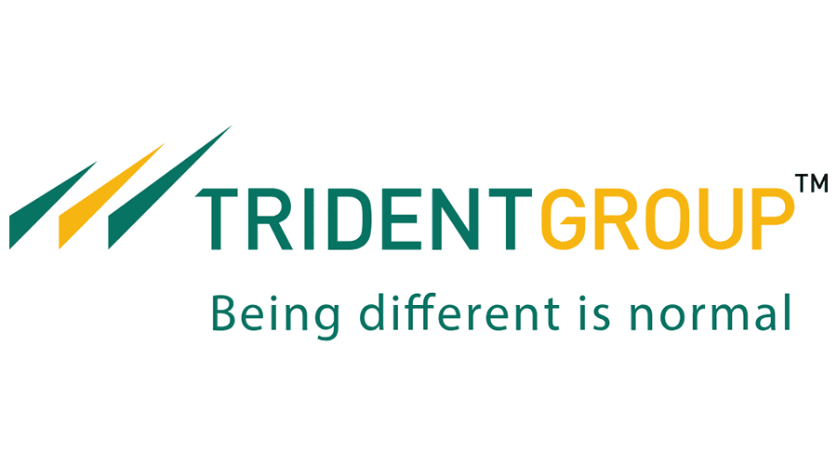
Project: To identify Value added products that can be manufactured
From Sulphuric Acid under Product Development in
Chemicals Division.

Submitted To: Submitted by:
Naveet Jindal - CEO Marketing Paper and Chemicals Chinmay Soni
Mr. P.S. Bindra- Key account Manager MBA
Batch: 2018-2020

ACKNOWLEDGEMENT

It is my pleasure to be indebted to various people, who directly or indirectly contributed in the development of this work and who influenced my thinking, behavior, and acts during the course of study.
I express my sincere gratitude to Department of Business Economics , Delhi university for providing me an opportunity to undergo summer training at Trident Group.
I extend my gratitude to Trident Group and Mr. Rajinder Gupta for giving me this opportunity.
I would like to express my deep and sincere gratitude to my mentors Mr. Naveet Jindal and Mr. P.S. Bindra for providing me invaluable guidance throughout this internship period. Their dynamism, vision, sincerity and motivation have deeply inspired me. It was a great privilege and honor to work and study under their guidance.
Lastly, I would like to thank the almighty and my parents for their moral support and my friends who helped me during this internship period.

Executive Summary

The internship period in Trident had been 03rd June’19 till 03th Aug’19. The Project related relevant information was provided on 7th June, under the guidance of Mr. Naveet Jindal (CEO, Paper and Chemicals) and Mr. P.S. Bindra (Key Accounts Manager, US region). The first part of my project involved studying the internal business processes of Sales and Marketing department of Chemicals, ranging from Demand, Revenue, Sales,Supply and Prices ,till Customer payments/ Complaints (if any).Simultaneously, a survey was prepared to analyze the factors affecting different dealers of Sulphuric Acid. Due attention was paid to gain inputs from all the teams. Qualitative research has been carried out to gain inputs from Dealers from all the major Chemicals. N no. Of chemicals have been identified , with major focus on value added products from Sulphuric acid
Among different parameters such as Demand, Supply, Prices, Competitors, Uses.

Phosphoric Acid came out to be most Favourable product out of all the research methodologies used.

Table of Contents

ACKNOWLEDGEMENT 2
EXECUTIVE SUMMARY.................................................................................................3
ABOUT THE BUSINESS 4
PRODUCT DEVELOPMENT ......................................................................................5
SOURCES...........................................................................................................................6
QUESTIONNAIRE.............................................................................................................7
RECOMMENDATION
INPUTS .........................................................................................................................9
CONCLUSION 11
FEASIBILITY-PHOSPHORIC ACID .............................................................................12
BIBLIOGRAPHY 1
3

ABOUT THE CHEMICAL BUSINESS

Started as Varindra Agro Chemicals Ltd. in the year 1985 with an initial production capacity of 36300 TPA of Sulphuric Acid. i.e.100 TPD . This plant was originally set up at Sanghera and was later shifted to Dhaula in the year 1997 and it’s production capacity was also escalated to 100,000 TPA in the same year. i.e. 275 TPD. In 2010 Trident Chemicals have extended with the state of the art technology plant imported from QVF Germany to add up a new product line Sulphuric Acid LR with the production capacity of 33 TPD.

Trident Limited, the leading Sulphuric Acid manufacturer in India, offering superior quality and improved efficiency, brings to you LR/AR Grade Sulphuric Acid based on Borosilicate Glass make Facility from De Dietrich Process Systems – Germany, world leaders in the field of glass plants. As a result, our plant bears the distinction of having the largest capacity for LR/AR grade Sulphuric Acid in India. Thereby offering superior quality, more consistency, bigger scale and improved efficiency.Consumers include detergent manufacturers, iron & steel units, textile factories, pharmaceuticals, paper industry, dyes and chemicals, alum, detergent slurry, & ETP.

Sulphuric acid, (chemical formula H2SO4) known as oil of vitriol, is a oily viscous liquid corrosive in nature, is a basic commodity chemical. Trident specializes in three grades of Sulphuric Acid which differ in composition and hence serve several different applications

PRODUCT DEVELOPMENT :VALUE ADDED PRODUCTS FROM SULPHURIC ACID

ANSOFF MATRIX USED FOR PRODUCT DEVELOPMENT STRATEGY

Sometimes called the Product/Market Expansion Grid, the Matrix (see figure 1, below) shows four strategies you can use to grow. It also helps you analyze the risks associated with each one. The idea is that each time you move into a new quadrant (horizontally or vertically), risk increases.
Figure 1: The Ansoff Matrix
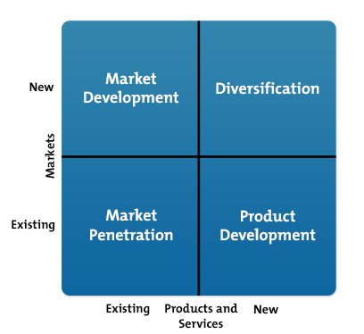
Market penetration, in the lower left quadrant, is the safest of the four options. Here, you focus on expanding sales of your existing product in your existing market: you know the product works, and the market holds few surprises for you.
Product development, in the lower right quadrant, is slightly more risky, because you're introducing a new product into your existing market.
With market development, in the upper left quadrant, you're putting an existing product into an entirely new market. You can do this by finding a new use for the product, or by adding new features or benefits to it.
Diversification, in the upper right quadrant, is the riskiest of the four options, because you're introducing a new, unproven product into an entirely new market that you may not fully understand.

Product Development

Value Added Products From Sulphuric Acid

PRODUCTS IDENTIFIED

- Phosphoric Acid
- Ammonium Sulphate
- Hydrofluoric Acid
- Chlorosulphonic Acid
- Dimethyl Sulphate
- Sulphamic Acid
- Oleum
- Poly Aluminum Chloride (PAC) – Identified from Market Survey
- Acid Slurry – Identified from Market survey
- Single Super Phoshate

Sources of Survey
- Internet
- Library
- Cold calling
- Secondary research meeting Dealers

QUESTIONNAIRE

- Any generalized information about the products if any?
- Who are the major producers of the same chemical?
- Effective Demand In Punjab/North Region ?
- Feasibility in Producing the same?
- Major Consumers?
- What is the current prevailing price in the market?
- Best to produce among all set of chemicals?
Phosphoric Acid
Ammonium Sulphate
Hydrofluoric Acid
Chlorosulphonic Acid
Dimethyl Sulphate
Sulphamic Acid
Oleum
Poly Aluminum Chloride (PAC)
Acid Slurry
Single Super Phosphate
- Any other source of information which will be helpfull for the survey?
- Any other value added products you want to suggest?

Places Visited Chandigarh, Ludhiana local market, Delhi.

Total no. of Dealers Visited= 14

Recommendation and Demand according to Producers

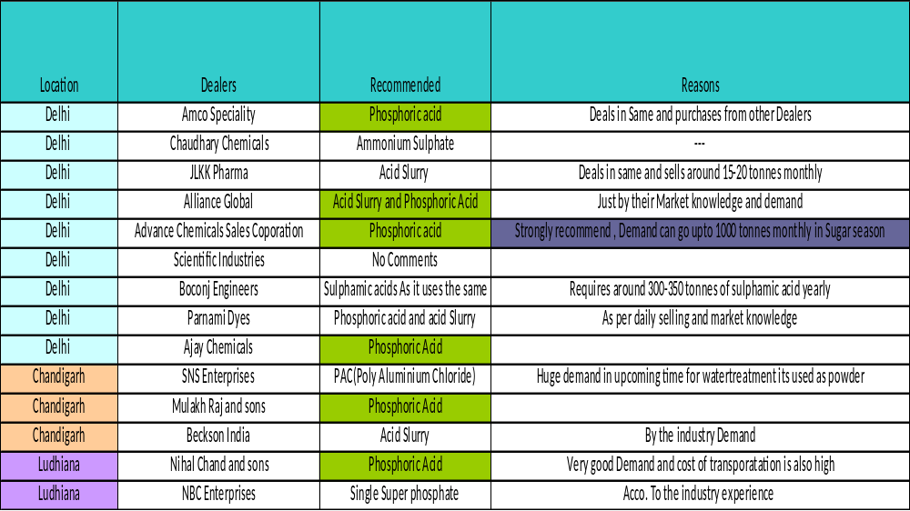

Inputs and Recommendation

Alliance Global
- Only in the business of some chemicals
- Phosphoric Acid –Priced at 60-65/kg(Manufacturer price)
- Acid slurry (Most demanded of all chemicals but there are many small manufacturers) Priced at 85/kg for 90%, requirement of 200-300
tonnes monthly

Advance chemicals Sales Corporation
- Suphamic acid monthly required in north region around 100-200 tonnes priced at 28-30/kg.
(Mostly used in herbicides, descalant and dying)
- Phosphoric Acid required around 500 tonnes in north region but in sugar season can go upto 1000 tonnes . Mostly required food grade (60/kg). Current manufacturers (Aditya birla ,punjab alkalies)
- Only Wet process of manufacturing uses Sulphuric Acid and demand will depend on purity which can be manufactured . Mostly market uses From thermal process
- Phosphoric manufactured by Thermal process all time versatile.
- Acid slurry 90% at 80/kg manufactured by Phogla group and Advance surfactants.
- Ammonium Sulphate can be known only through Fertilizer route
- Hydrofluoric Acid in different purity around 40,50,60% with major manufacturer as Tanfac, Naveen fluorics.
- PAC(poly Aluminium Chloride) 30-32/kg mostly by Grasim

Scientific Industries
- Doesn’t Deal with Commercial market only in lab chemicals.
- Recommended for Chemical weekly –PUBLISHED FROM BOMBAY

Boconj Engineers
- Only require Sulphamic Acid and oleum around 300-400 tonnes , if supplied below their price.
- Rest no Data regarding other chemicals but recommended for Phosphoric Acid.

JLKK Pharma
- Not regular demand mostly Food chemicals
- Uses acid slurry around 15-20 tonnes (Monthly) from Mumbai and Gujarat
- Sulphamic acid requirement of 10-12 tonnes monthly
- Potassium Sulphate 5-6 tonnes monthly

Amco industries
- (Second Dealer of acids such as Phosphoric, Hydrofluoric, Sulfuric –All washing Chemicals) (Can become a potential customer)
- Buys PHOSPHORIC Acid At Around 80/kg and hydrofluoric at 90/kg
- Used in washing and Metal Treatment (Approx Delhi Consumption monthly -400 tonnes)
- Requires Sulphuric Acid(Commercial Grade) At 8-8.5 /kg (monthly requirement of 25-35 tonnes)

Parnami Dyes
- Recommended for Phosphoric Acid and Acid slurry used in huge quantity with Major demand in the market.

Ajay chemicals
- Recommended for Acid Slurry and Phosphoric Acid

Recommendation As a %age of different Dealers

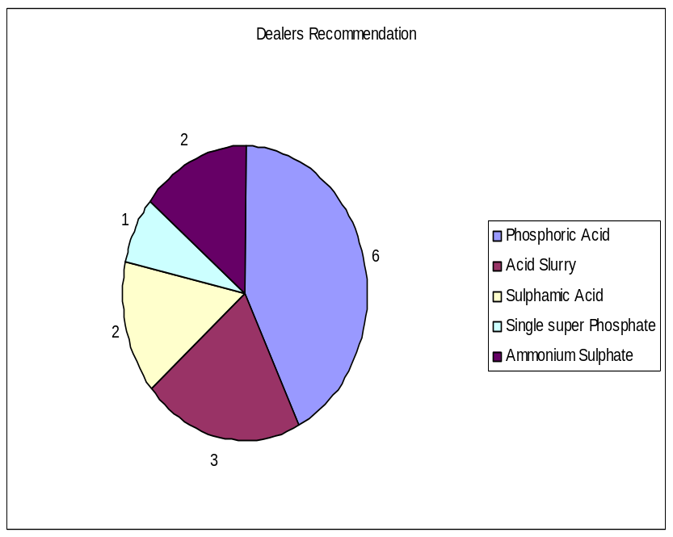

Out of all the Dealers met in Ludhiana ,Chandigarh ,Delhi
6 dealers recommended for PHOSPHORIC ACID
3 recommended for Acid Slurry
2 recommended for Sulphamic Acid
2 for ammonium Sulphate
1 recommended for Single super Phosphate

IMPORTANT CONCLUSIONS

- Out of 14 dealers visited across places such as Delhi, Ludhiana, Chandigarh and all the primary Research done Phosphoric Acid tops the Product List with Highest Demand and less Supply .

- Phosphoric Acid to be manufactured by Wet process which uses sulphuric Acid should be manufactured with high quality output.

- Most of the manufacturers of phosphoric acid lie around Gujarat region which increases the transportation cost.

- Acid slurry and Sulphamic Acid have the most demand after phosphoric acid and is required in some niche areas

- PAC (Powder form) can also turn out to be one of the important products as the Growing demand of water treatment in the present scenario.

- OLEUM has been totally replaced by acid slurry in market .

PHOSPHORIC ACID FEASIBILITY

Phosphoric acid (H3PO4) is produced by 2 commercial methods: Wet process and Thermal process

Wet process phosphoric acid is used in fertilizer production.
Thermal process phosphoric acid is of a much higher purity and is used in the manufacture of high grade chemicals, pharmaceuticals, detergents, food products, beverages, and other NON-Fertilizer products.

WET Process
Wet Process of Production of Phosphoric Acid which Uses Sulphuric AcidIn a wet process facility , phosphoric acid is produced by reacting sulfuric acid (H2SO4) with naturally occurring phosphate rock.
The phosphate rock is dried, crushed, and then continuously fed into the reactor along with sulfuric acid. The reaction combines calcium from the phosphate rock with sulfate, forming calcium sulfate (CaSO4), commonly referred to as gypsum. Gypsum is separated from the reaction solution by filtration.
Facilities in the U. S. generally use a dihydrate process that produces gypsum in the form of calcium sulfate with 2 molecules of water (H2O) (CaSO4 2 H2O or calcium sulfate dihydrate).
Japanese facilities use a hemihydrate process that produces calcium sulfate with a half molecule of water (CaSO4 ½ H2O). This one-step hemihydrate process has the advantage of producing wet process phosphoric acid with a higher P2O5 concentration and less impurities than the dihydrate process
Due to these advantages, some U. S. companies have recently converted to the hemihydrate process. However, since most wet process phosphoric acid is still produced by the dihydrate process, the hemihydrate process will not be discussed in detail here.
A simplified reaction for the dihydrate process is as follow:

Ca (1) 3(PO4)2 3H2SO4 6H2O → 2H3PO4 3[CaSO4 2H2O]↓

In order to make the strongest phosphoric acid possible and to decrease evaporation costs, 93 percent sulfuric acid is normally used. Because the proper ratio of acid to rock in the reactor is critical, precise automatic process control equipment is employed in the regulation of these 2 feed streams.
During the reaction, gypsum crystals are precipitated and separated from the acid by filtration. The separated crystals must be washed thoroughly to yield at least a 99 percent recovery of the filtered phosphoric acid.
Wet process phosphoric acid normally contains 26 to 30 percent P2O5. In most cases, the acid must be further concentrated to meet phosphate feed material specifications for fertilizer production.
Depending on the types of fertilizer to be produced, phosphoric acid is usually concentrated to 40 to 55 percent P2O5 by using 2 or 3 vacuum evaporators.

BIBLIOGRAPHY

- Annual reports of Trident : 2016-2018
- Report on PRODUCTION OF PHOSPHORIC ACID 2000 EFMA European Fertilizer Manufacturers’ Association
- F. No. 11017/1/2017-M&E Government of India M/o Chemicals and Fertilizers D/o Fertilizers E&S Wing) Monthly Bulletin for the month of June, 2018
- https://www.echemi.com/productsInformation/pd20150901061-phosphoric-acid.html
- https://www.infodriveindia.com/indian-importers/phosphoric-acid-importers.aspx
- http://www.essentialchemicalindustry.org/chemicals/phosphoric-acid.html
- https://ihsmarkit.com/products/phosphoric-acid-chemical-economics-handbook.html
- https://www.zauba.com/exportanalysis-phosphoric+acid-report.html
- https://www.researchgate.net/publication/318397493_Phosphoric_Acid_Industry_Problems_and_Solutions
- https://www.icis.com/explore/resources/news/2018/07/06/10239023/phosphates-prices-up-on-good-demand-tight-supply-and-higher-feedstock-costs/
- https://www.jmbaxigroup.com/newsletter/issue-xviii/phosphoric-acid-imports-into-india/
- http://www.inchem.org/documents/jecfa/jecmono/v38aje10.htm
- Secondary survey after Meeting Dealers

